Features of Java
The primary objective of Java programming language creation was to make it portable, simple and secure programming language. Apart from this, there are also some excellent features which play an important role in the popularity of this language. The features of Java are also known as Java buzzwords.
A list of the most important features of the Java language is given below.
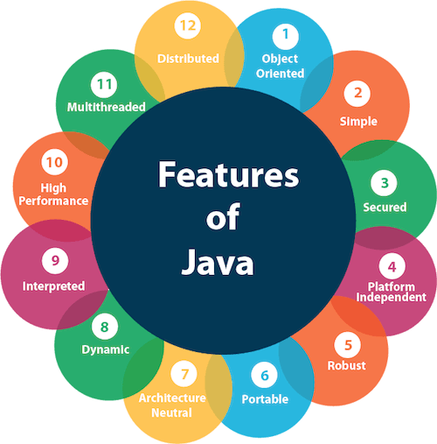
- Simple
- Object-Oriented
- Portable
- Platform independent
- Secured
- Robust
- Architecture neutral
- Interpreted
- High Performance
- Multithreaded
- Distributed
- Dynamic

Simple
Java is very easy to learn, and its syntax is simple, clean and easy to understand. According to Sun Microsystem, Java language is a simple programming language because:
- Java syntax is based on C++ (so easier for programmers to learn it after C++).
- Java has removed many complicated and rarely-used features, for example, explicit pointers, operator overloading, etc.
- There is no need to remove unreferenced objects because there is an Automatic Garbage Collection in Java.

Object-oriented
Java is an object-oriented programming language. Everything in Java is an object. Object-oriented means we organize our software as a combination of different types of objects that incorporate both data and behavior.
Object-oriented programming (OOPs) is a methodology that simplifies software development and maintenance by providing some rules.
Basic concepts of OOPs are:
- Object
- Class
- Inheritance
- Polymorphism
- Abstraction
- Encapsulation

Platform Independent
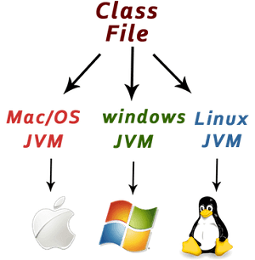
Java is platform independent because it is different from other languages like C, C++, etc. which are compiled into platform specific machines while Java is a write once, run anywhere language. A platform is the hardware or software environment in which a program runs.
There are two types of platforms software-based and hardware-based. Java provides a software-based platform.
The Java platform differs from most other platforms in the sense that it is a software-based platform that runs on top of other hardware-based platforms. It has two components:
- Runtime Environment
- API(Application Programming Interface)
Java code can be executed on multiple platforms, for example, Windows, Linux, Sun Solaris, Mac/OS, etc. Java code is compiled by the compiler and converted into bytecode. This bytecode is a platform-independent code because it can be run on multiple platforms, i.e., Write Once and Run Anywhere (WORA).

Secured
Java is best known for its security. With Java, we can develop virus-free systems. Java is secured because:
- No explicit pointer
- Java Programs run inside a virtual machine sandbox
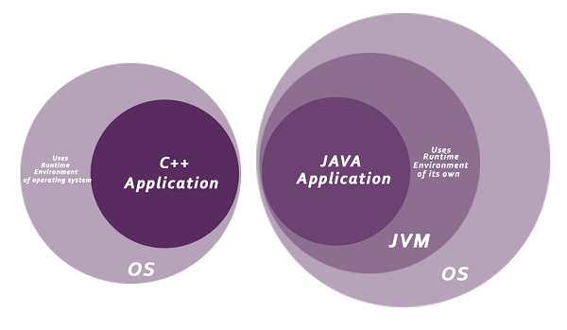
- Classloader: Classloader in Java is a part of the Java Runtime Environment (JRE) which is used to load Java classes into the Java Virtual Machine dynamically. It adds security by separating the package for the classes of the local file system from those that are imported from network sources.
- Bytecode Verifier: It checks the code fragments for illegal code that can violate access rights to objects.
- Security Manager: It determines what resources a class can access such as reading and writing to the local disk.
Java language provides these securities by default. Some security can also be provided by an application developer explicitly through SSL, JAAS, Cryptography, etc.

Robust
The English mining of Robust is strong. Java is robust because:
- It uses strong memory management.
- There is a lack of pointers that avoids security problems.
- Java provides automatic garbage collection which runs on the Java Virtual Machine to get rid of objects which are not being used by a Java application anymore.
- There are exception handling and the type checking mechanism in Java. All these points make Java robust.

Architecture-neutral
Java is architecture neutral because there are no implementation dependent features, for example, the size of primitive types is fixed.
In C programming, int data type occupies 2 bytes of memory for 32-bit architecture and 4 bytes of memory for 64-bit architecture. However, it occupies 4 bytes of memory for both 32 and 64-bit architectures in Java.

Portable
Java is portable because it facilitates you to carry the Java bytecode to any platform. It doesn't require any implementation.

High-performance
Java is faster than other traditional interpreted programming languages because Java bytecode is "close" to native code. It is still a little bit slower than a compiled language (e.g., C++). Java is an interpreted language that is why it is slower than compiled languages, e.g., C, C++, etc.

Distributed
Java is distributed because it facilitates users to create distributed applications in Java. RMI and EJB are used for creating distributed applications. This feature of Java makes us able to access files by calling the methods from any machine on the internet.

Multi-threaded
A thread is like a separate program, executing concurrently. We can write Java programs that deal with many tasks at once by defining multiple threads. The main advantage of multi-threading is that it doesn't occupy memory for each thread. It shares a common memory area. Threads are important for multi-media, Web applications, etc.

Dynamic
Java is a dynamic language. It supports the dynamic loading of classes. It means classes are loaded on demand. It also supports functions from its native languages, i.e., C and C++.
Java supports dynamic compilation and automatic memory management (garbage collection).

JVM (Java Virtual Machine) Architecture
JVM (Java Virtual Machine) is an abstract machine. It is a specification that provides runtime environment in which java bytecode can be executed.
JVMs are available for many hardware and software platforms (i.e. JVM is platform dependent).

What is JVM
It is:
- A specification where working of Java Virtual Machine is specified. But implementation provider is independent to choose the algorithm. Its implementation has been provided by Oracle and other companies.
- An implementation Its implementation is known as JRE (Java Runtime Environment).
- Runtime Instance Whenever you write java command on the command prompt to run the java class, an instance of JVM is created.

What it does
The JVM performs following operation:
Backward Skip 10sPlay VideoForward Skip 10s
ADVERTISEMENT
ADVERTISEMENT
ADVERTISEMENT
- Loads code
- Verifies code
- Executes code
- Provides runtime environment
JVM provides definitions for the:
- Memory area
- Class file format
- Register set
- Garbage-collected heap
- Fatal error reporting etc.

JVM Architecture
Let's understand the internal architecture of JVM. It contains classloader, memory area, execution engine etc.
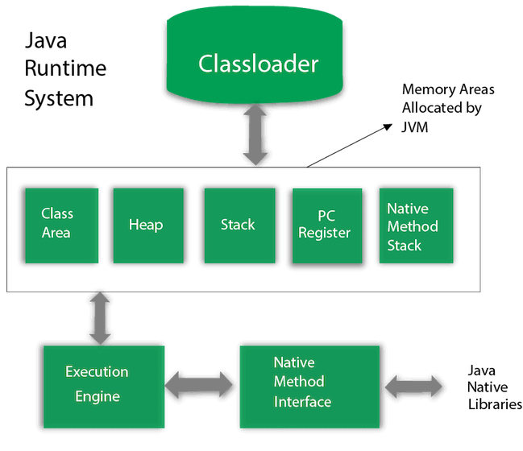

1) Classloader
Classloader is a subsystem of JVM which is used to load class files. Whenever we run the java program, it is loaded first by the classloader. There are three built-in classloaders in Java.
- Bootstrap ClassLoader: This is the first classloader which is the super class of Extension classloader. It loads the rt.jar file which contains all class files of Java Standard Edition like java.lang package classes, java.net package classes, java.util package classes, java.io package classes, java.sql package classes etc.
- Extension ClassLoader: This is the child classloader of Bootstrap and parent classloader of System classloader. It loades the jar files located inside $JAVA_HOME/jre/lib/ext directory.
- System/Application ClassLoader: This is the child classloader of Extension classloader. It loads the classfiles from classpath. By default, classpath is set to current directory. You can change the classpath using "-cp" or "-classpath" switch. It is also known as Application classloader.
- //Let's see an example to print the classloader name
- public class ClassLoaderExample
- {
- public static void main(String[] args)
- {
- // Let's print the classloader name of current class.
- //Application/System classloader will load this class
- Class c=ClassLoaderExample.class;
- System.out.println(c.getClassLoader());
- //If we print the classloader name of String, it will print null because it is an
- //in-built class which is found in rt.jar, so it is loaded by Bootstrap classloader
- System.out.println(String.class.getClassLoader());
- }
- }

Output:
sun.misc.Launcher$AppClassLoader@4e0e2f2a
null
These are the internal classloaders provided by Java. If you want to create your own classloader, you need to extend the ClassLoader class.

2) Class(Method) Area
Class(Method) Area stores per-class structures such as the runtime constant pool, field and method data, the code for methods.
ADVERTISEMENT
ADVERTISEMENT

3) Heap
It is the runtime data area in which objects are allocated.

4) Stack
Java Stack stores frames. It holds local variables and partial results, and plays a part in method invocation and return.
Each thread has a private JVM stack, created at the same time as thread.
A new frame is created each time a method is invoked. A frame is destroyed when its method invocation completes.

5) Program Counter Register
PC (program counter) register contains the address of the Java virtual machine instruction currently being executed.

6) Native Method Stack
It contains all the native methods used in the application.

7) Execution Engine
It contains :
- A virtual processor
- Interpreter: Read bytecode stream then execute the instructions.
- Just-In-Time(JIT) compiler: It is used to improve the performance. JIT compiles parts of the byte code that have similar functionality at the same time, and hence reduces the amount of time needed for compilation. Here, the term "compiler" refers to a translator from the instruction set of a Java virtual machine (JVM) to the instruction set of a specific CPU.

8) Java Native Interface
Java Native Interface (JNI) is a framework which provides an interface to communicate with another application written in another language like C, C++, Assembly etc. Java uses JNI framework to send output to the Console or interact with OS libraries.

What is JRE?
Java Run-time Environment (JRE) is the part of the Java Development Kit (JDK). It is a freely available software distribution which has Java Class Library, specific tools, and a stand-alone JVM. It is the most common environment available on devices to run java programs. The source Java code gets compiled and converted to Java bytecode. If you wish to run this bytecode on any platform, you require JRE. The JRE loads classes, verify access to memory, and retrieves the system resources. JRE acts as a layer on the top of the operating system.
It also includes:
ADVERTISEMENT
ADVERTISEMENT
- Technologies which get used for deployment such as Java Web Start.
- Toolkits for user interface like Java 2D.
- Integration libraries like Java Database Connectivity (JDBC) and Java Naming and Directory Interface (JNDI).
- Libraries such as Lang and util.
- Other base libraries like Java Management Extensions (JMX), Java Native Interface (JNI) and Java for XML Processing (JAX-WS).

What does JRE consist of?
JRE consists of the following components:
- Deployment technologies such as deployment, Java plug-in, and Java Web Start.
- User interface toolkits, including Abstract Window Toolkit (AWT), Swing, Java 2D, Accessibility, Image I/O, Print Service, Sound, drag, and drop (DnD) and input methods.
- Integration libraries including Interface Definition Language (IDL), Java Database Connectivity (JDBC), Java Naming and Directory Interface (JNDI), Remote Method Invocation (RMI), Remote Method Invocation Over Internet Inter-Orb Protocol (RMI-IIOP) and scripting.
- Other base libraries, including international support, input/output (I/O), extension mechanism, Beans, Java Management Extensions (JMX), Java Native Interface (JNI), Math, Networking, Override Mechanism, Security, Serialization and Java for XML Processing (XML JAXP).
- Lang and util base libraries, including lang and util, zip, Java Archive (JAR), instrument, reflection, Collections, Concurrency Utilities, management, versioning, Logging, Preferences API, Ref Objects and Regular Expressions.
- Java Virtual Machine (JVM), which comprise of Server Virtual Machine and Java HotSpot Client.

How does JRE work with JVM?
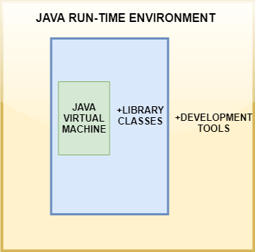
JRE has an instance of JVM with it, library classes and development tools. To understand the working of JRE let us see an example of a simple "Hello World" program.
Backward Skip 10sPlay VideoForward Skip 10s
ADVERTISEMENT
- import java.util.*
- public static void main(String[] args){
- System.out.println(?Hello world?);
- }
Once you write this program, you have to save it with .java extension. Compile your program. The output of the Java compiler is a byte-code which is platform independent. After compiling, the compiler generates a .class file which has the bytecode. The bytecode is platform independent and runs on any device having the JRE. From here, the work of JRE begins. To run any Java program, you need JRE. The flow of the bytecode to run is as follows:
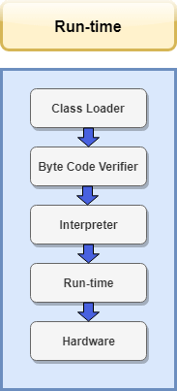
The following steps take place at runtime:
- Class Loader
At this step, the class loader loads various classes which are essential for running the program. The class loader dynamically loads the classes in the Java Virtual Machine.
When the JVM is started, three class loaders are used:
  - Bootstrap class loader
  - Extensions class loader
  - System class loader
- Byte code verifier
Byte code verifier can be considered as a gatekeeper. It verifies the bytecode so that the code doesn't make any sort of disturbance for the interpreter. The code is allowed to be interpreted only when it passes the tests of the Bytecode verifier which checks the format and checks for illegal code.
- Interpreter
Once the classes get loaded and the code gets verified, then interpreter reads the assembly code line by line and does the following two functions:
  - Execute the Byte Code
  - Make appropriate calls to the underlying hardware
In this way, the program runs in JRE.

How to set up Java JRE with PATH Environment Variables?
To develop or run Java applications, you need to download and install the Java SE Development Kit.
Step 1.) Download the Java SE latest release from the official site of the oracle.
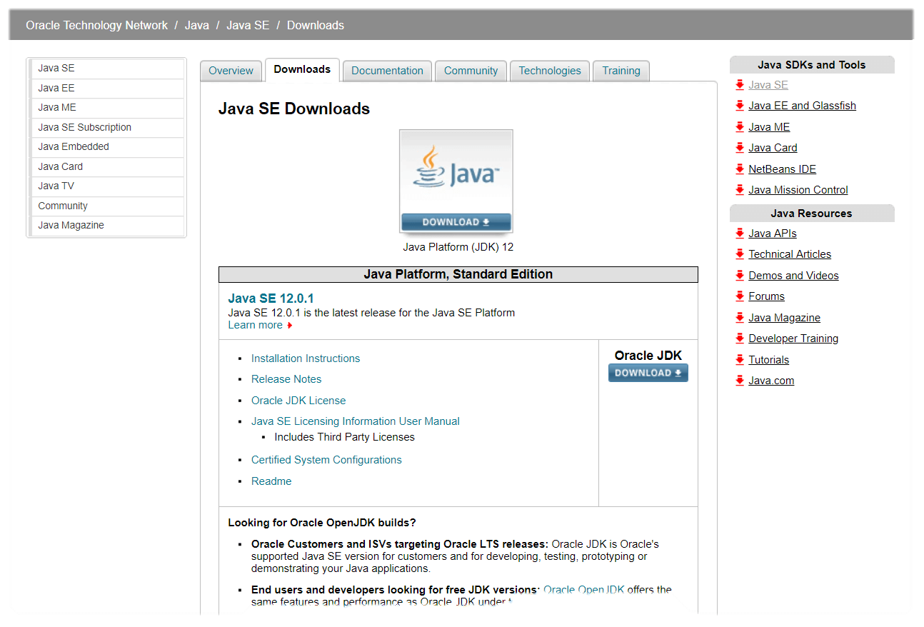
Step 2.) After downloading the file, you will have an executable file downloaded. Run that file and keep everything as default and keep clicking next and then install.
Step 3.) After completing the installation, your JDK and JRE would be downloaded in the program files folder.
Step 4.) After complete installation, you need to set up the environment variables.
Step 5.) Go to control panel -> System and Security -> System -> Advanced System Settings. The following dialog box will appear.
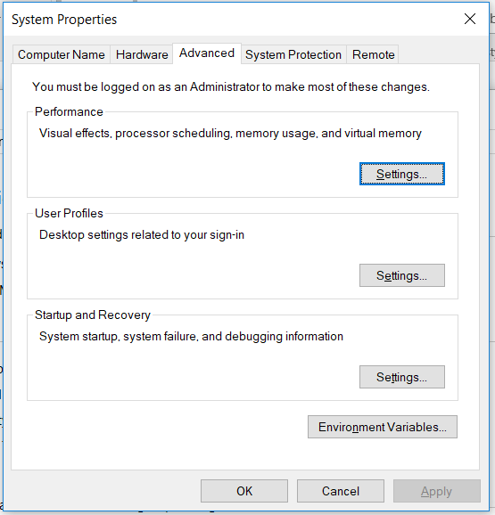

Step 6.) Click on Environment Variables, go to system variables, and double click on Path.
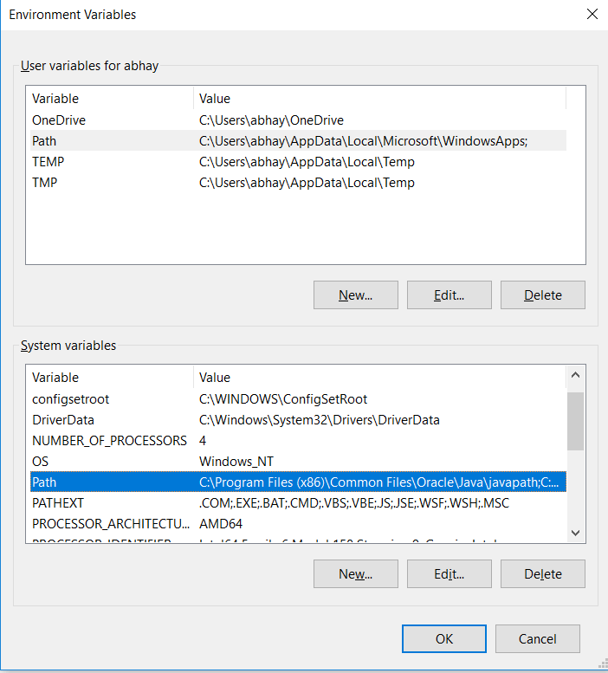

Step 7.) Now add the path of your bin file present in the JRE file to the Path variable.
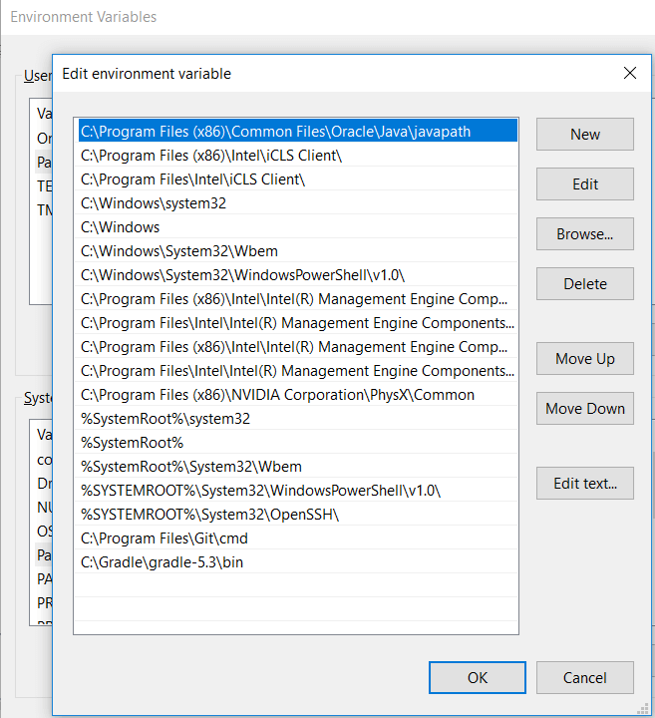
The set up Java environment is complete.

Difference between JVM, JDK, and JRE
- JVM - Java Virtual Machine is a virtual machine which runs programs which are compiled to bytecodes. The JVM is detailed by a specification that formally describes what is required in a JVM implementation. Having a specification ensures interoperability of Java programs across different implementations so that program authors using the Java Development Kit (JDK) need not worry about traits of the underlying hardware platform.
- JDK- JDK is a wrapper around the JRE and additionally contains the compiler, interpreter, debugger and other tools. It provides users with features to run as well as develop Java programs.
- JRE- JRE is made up of class libraries, JVM and supporting files

JDK in Java

The Java Development Kit (JDK) is a cross-platformed software development environment that offers a collection of tools and libraries necessary for developing Java-based software applications and applets. It is a core package used in Java, along with the JVM (Java Virtual Machine) and the JRE (Java Runtime Environment).
Beginners often get confused with JRE and JDK, if you are only interested in running Java programs on your machine then you can easily do it using Java Runtime Environment. However, if you would like to develop a Java-based software application then along with JRE you may need some additional necessary tools, which is called JDK.
JDK=JRE+Development Tools
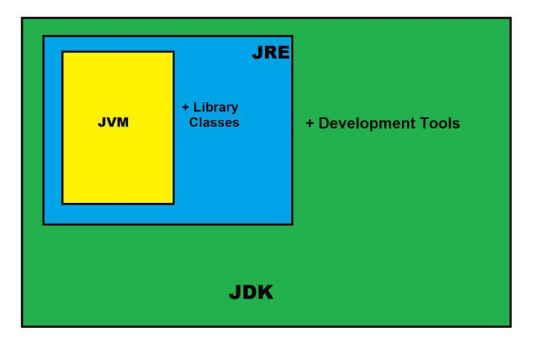
JAVA Development Kit (JDK)

The Java Development Kit is an implementation of one of the Java Platform:
- Standard Edition (Java SE),
- Java Enterprise Edition (Java EE),
- Micro Edition (Java ME),

Contents of JDK
The JDK has a private Java Virtual Machine (JVM) and a few other resources necessary for the development of a Java Application.
All Your Queries Answered | DSA to Development Program | GeeksforGeeks

JDK contains:
- Java Runtime Environment (JRE),
- An interpreter/loader (Java),
- A compiler (javac),
- An archiver (jar) and many more.
The Java Runtime Environment in JDK is usually called Private Runtime because it is separated from the regular JRE and has extra content. The Private Runtime in JDK contains a JVM and all the class libraries present in the production environment, as well as additional libraries useful to developers, e.g, internationalization libraries and the IDL libraries.

Most Popular JDKs:
- Oracle JDK: the most popular JDK and the main distributor of Java11,
- OpenJDK: Ready for use: JDK 15, JDK 14, and JMC,
- Azul Systems Zing: efficient and low latency JDK for Linux os,
- Azul Systems: based Zulu brand for Linux, Windows, Mac OS X,
- IBM J9 JDK: for AIX, Linux, Windows, and many other OS,
- Amazon Corretto: the newest option with the no-cost build of OpenJDK and long-term support.

Set-Up:
Setting up JDK in your development environment is super easy, just follow the below simple steps.
Installation of JDK
- Go to this Oracle’s official Download Page through this link
- Select the latest JDK version and click Download and add it to your classpath.
- Just check the JDK software is installed or not on your computer at the correct location, for example, at C:\Program Files\Java\jdk11.0.9.
Set JAVA_HOME for Windows:
- Right-click My Computer and select Properties.
- Go to the Advanced tab and select Environment Variables, and then edit JAVA_HOME to point to the exact location where your JDK software is stored, for example, C:\Program Files\Java\jdk11.0.9 is the default location in windows.
Java maintains backward compatibility, so don’t worry just download the latest release and you will get all the old and many new features. After Installing the JDK and JRE adds the java command to your command line. You can verify this through the command prompt by the java -version command. In some cases, you need to restart your system after installing the JDK.
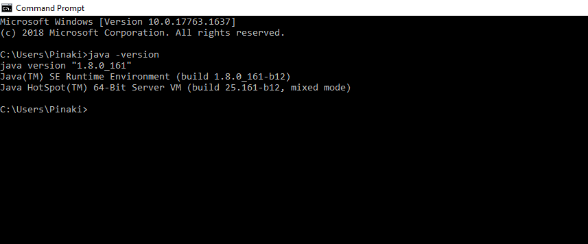
JDK Version

Compile and Run Java Code using JDK:
You can use the JDK compiler to convert your Java text file into an executable program. Your Java text segment is converted into bytecode after compilation which carries the .class extension.
First, create a Java text file and save it using a name. Here we are saving the file as Hello.java.
- Java
class Hello{
public static void main (String[] args) {
System.out.println("Hello Geek!");
}
}
After that just simply use the javac command, which is used for the compilation purpose in Java. Please don’t forget to provide the full path of your java text file to the command line else you will get an error as “The system cannot find the path specified”,
Your command should be similar to the given below example where Hello is the file name and the full path to the file is specified before the file name. The path and javac.exe should be inside the quotes.
“C:\Program Files\Java\jdk-11.0.9\bin\javac.exe” Hello.java
You can notice now that the Hello.class file is being created in the same directory as Hello.java. Now you can run your code by simply using the java Hello command, which will give you the desired result according to your code. Please remember that you don’t have to include the .class to run your code.
C:\Users\Pinaki\Documents>java hello_world
(Output:) Hello Geek!

The Jar component:
JDK contains many useful tools and among them, the most popular after javac is the jar tool. The jar file is nothing but a full pack of Java classes. After creating the .class files, you can put them together in a .jar, which compresses and structures them in a predictable fashion. Now, let’s convert our Hello.class to a jar file.
Before proceeding, please note that you should be in the same directory where the Hello.java file was saved. Now type the command given below in the command line.
Creating a .jar file
C:\Users\Pinaki\Documents>”c:\Program Files\Java\jdk-11.0.9\bin\jar.exe” –create –file Hello.jar Hello.class
Now you can notice that Hello.jar file had been created in the same directory using Hello.class file and jar.exe. You can use the jar file by adding it to your classpath and executing the program inside it. Here the -cp stands for classpath which helps to add the jar to the same classpath.
Executing the .jar file
java -cp hello_world.jar hello_world

Important Components of JDK
Below there is a comprehensive list of mostly used components of Jdk which are very useful during the development of a java application.
Component | Use
javac | Java compiler converts source code into Java bytecode
java | The loader of the java apps.
javap | Class file disassembler,
javadoc | Documentation generator,
jar | Java Archiver helps manage JAR files.
appletviewer | Debugging of Java applets without a web browser,
xjc | Accepts an XML schema and generates Java classes,
apt | Annotation-processing tool,
jdb | Debugger,
jmc | Java Mission Control,
JConsole | Monitoring and Management Console,
pack200 | JAR compression tool,
extcheck | Utility tool to detects JAR file conflicts,
idlj | IDL-to-Java compiler,
keytool | The keystore manipulating tool,
jstatd | jstat daemon (experimental)
jstat | JVM statistics monitoring tool
jshell | jshell introduced in java 9.
jstack | Prints Java stack traces(experimental)
jrunscript | Java command-line script shell.
jhat | Java Heap Analysis Tool (experimental)
jpackage | Generate self-contained application bundles.
javaws | Web Start launcher for JNLP applications,
javah | C header and stub generator,
jarsigner | jar signing and verification tool
jinfo | configuration information(experimental)
javafxpackager | Package and sign JavaFX applications

Basic Libraries in Java
Here are some of the libraries used in Java:

1) Java Standard Libraries
Begin with the foundational frameworks and libraries the Java programming language provides. Java Standard Libraries, often overlooked, include robust and functional libraries like java.util, java.lang, java.math, java.net, and java.io/java.nio. These libraries form the cornerstone for building a solid programming base, aiding in understanding third-party libraries effectively.

2) Mockito [Unit Testing Library]
Mockito, an open-source mocking framework, is essential for Java developers proficient in conducting unit tests. With a clean and simple API, Mockito facilitates the creation of test double objects for behavior-driven and test-driven scenarios. Voted as the best mocking framework for Java on StackOverflow, Mockito is a valuable tool in a developer’s testing arsenal.

3) Apache Commons [General-Purpose Library]
Apache Commons, an Apache project, encompasses a range of reusable Java components. This general-purpose library includes modules such as Commons IO, Commons Numbers, Commons Text, Commons CSV, Commons BSF, and Commons Crypto. Java developers can leverage these resources without the need to reference additional sources.

4) Google Guava [General-Purpose Library]
Google Guava is an open-source library with core Java components as an alternative to Apache Commons. Offering advanced features beyond Apache Commons, Guava includes generic classes, string manipulation, I/O operations, caching, and graph libraries. Categorized into basic utilities, Google Collections library, and miscellaneous utilities, Guava stands out as one of the most popular Java libraries.
Also read: Full Stack Java Developer Syllabus (A Comprehensive Guide)

5) JUnit [Unit Testing Library]
JUnit, another unit testing framework, empowers Java programmers to create test cases and execute unit tests. Mastering unit testing tools like JUnit is crucial for bug fixing. JUnit creates new instances of the test class for each test run, emphasizing the importance of creating independent test cases.

6) Jackson [JSON Parsing Library]
Jackson, a widely used JSON parsing library, is renowned for its high performance, lightweight structure, and accuracy. It facilitates the serialization and mapping of Java objects to JSON and vice versa. Jackson is versatile in processing encrypted data in BSV, XML, CBOR, BSON, TOML, and others, supporting various data types and formats.

7) Log4j 2 [Logging Library]
Log4j, the most popular logging library for Java, has seen an upgrade in Log4j 2 to address issues faced in the original framework. With advanced features like improved filters and speed, extensibility, custom log levels, support for JSON, XML, YAML, and asynchronous loggers, Log4j 2 is a powerful tool for managing logging events.

8) HttpClient [HTTP Library]
Used for requesting and retrieving HTTP resources over the network, HttpClient supports both HTTP/1.1 and HTTP/2. It accommodates synchronous and asynchronous programming models, allowing Java developers to make multiple requests with configuration flexibility.

9) JAXB [XML Parsing Library]
Java Architecture for XML Binding (JAXB) is crucial for XML parsing, providing ways to bind XML schemas and Java representation. With features like reduced generated classes, smaller runtime libraries, validation capabilities, and support for Java to XML, JAXB is indispensable for tasks that involve XML functionalities, primarily since the Java Standard Library in Java 9 no longer supports them.

10) DBCP [Database Connection Pool Library]
Database Connection Pool (DBCP) libraries enhance interaction speed for Java developers integrating databases into applications. DBCP, such as Apache Commons DBCP 2, enables connection pooling, saving time and effort by pooling connections rather than creating individual DB connections for each user.

Java Top 10 Libraries
Java is one of the most popular programming languages. Java provides a rich set of libraries, and its standard Java library is a very powerful that contains libraries such as java.lang, java.util, and java.math, etc. Java provides more than thousands of libraries except standard libraries. Some of the most useful and popular libraries are as follows:
- Java Standard libraries
- Apache Commons
- Jackson
- Maven
- Google-json
- Log5j and Slf4j
- JUnit
- Google Guava
- JAXB
- HTTP Libraries
Let's understand each of the libraries one by one:

Java Standard Library

Java Standard Library is one of the most popular and used libraries, which contains a list of libraries to make work easier. These libraries are called at run time by JVM(Java Virtual Machine). It provides the following libraries:
- We cannot write any program in Java without String, Enum, Double, etc. The lang library provides everything to us for writing code in Java.
- In order to use data structures and collections in Java, we need util class because it contains the definition of all data structures and collections.
- In order to work with pipes and to read data from files, we need the io library. It allows developers to use files in their Java applications.
- The nio is another library that stands for non-blocking I/O and is an alternative to java.io library. By using it, we can get the advantage of intensive use of I/O operations.
- The math library is one of the libraries used for mathematical calculation, such as the sum of BigInteger or BigDecimal.
- In order to work with networks, connections, and sockets, java.net provides all the required classes for it. The net library is mostly used for developing network applications.
- The swing and java.awt are two libraries used to create GUI(Graphical User Interface). The java.awt is available in the older version of Java.
- sound is another library that is used for media content.

Apache Commons

Apache Commons is another library or can say it is an open-source project which focuses on all aspects of reusable Java components. It has three parts such as Commons Proper, Commons Sandbox, and Commons Dormant.
ADVERTISEMENT
ADVERTISEMENT
ADVERTISEMENT
- The Commons Proper contains reusable Java components.
- The Common Sandbox is basically a workspace to develop java components.
- The Commons Dormant is basically a repository that contains the inactive components
The Apache Commons has the following features:
- Java Classes.
- Mathematics and Statistics components.
- I/O utilities.
- Logging utilities.
- JDBC helper.
- Java Collections framework extension.

Jackson Libraries

In Java, we need to work with data of different types of formats. In software development, we have to save, load, and transfer data into various formats. The JSON format is one of the formats which is mostly used in software development. Besides JSON, there are many more data formats such as CSV, XML, BSON, and Avro.
Jackson library is basically a suite of data processing libraries. The Jackson JSON library is a parser/generator library for transferring a .class file into a JSON format or JSON string. The Java Jackson library provides data binding and annotations, which can convert POJO objects into data or generate POJO from data.

Maven Libraries

Just like Apache Commons, Maven is also provided by the Apache. It is a comprehensive tool that is based on the project object model. By using Maven, we can build java web and desktop applications. Maven is a repository that manages configurations, documentation, build configuration, and dependency by specifying them in the pom.xml file.
Maven helps us to add a set of jar files in each project, create the right project structure and build and deploy the project. In order to learn more about Maven, visit https://www.javatpoint.com/maven-tutorial.

Google-json
Google-json is similar to Jackson, which is mainly used to convert Java Objects to JSON and vice versa. We need to convert the Java object into JSON and other formats when developing mobile applications and writing and using Rest APIs in Java applications.
ADVERTISEMENT
ADVERTISEMENT
It provides methods such as toJson() and fromJson() for converting objects into JSON and vice versa. It has extensive support of Java generics and provides custom representations for objects. We can convert the pre-existing unmodifiable objects into JSON or can form them and generate them from the JSON by using the Google-json library.

Log5j and Slf4j
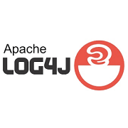
ADVERTISEMENT
Log5j is one of the light-weighted and fast logging libraries in Java. This library is available in Java5 or higher versions. Log5j is an advanced version of Log4j. In terms of style, it is similar to the Log4j, but it uses the varargs feature of Java which Log4j doesn't use. The varargs feature allows us to pass any number of arguments to any logging method.
Log5j also provides methods such as debugf, errorf, fatalf, logf, and tracef, which allow dynamic formatting of logging methods. These methods are very efficient when messages are not logged.
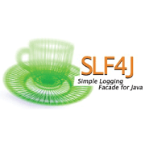
Slf4j stands for Simple Logging Facade for Java. It works as a simple facade or abstraction for various logging frameworks, which allows the end-user to plug in the desired logging framework at deployment time. In order to migrate the Java source code with Slf4j, there are several migration tools available in the market which easily migrate our projects to use the Slf4j API.

JUnit

Junit is one of the most important Java frameworks for writing unit tests. Nobody wants to write the code without producing tests. Everyone includes JUnit in their projects without starting code in Java. JUnit library allows developers to write tests for our code. It provides annotations and asserts classes for writing tests in Java.
In order to learn more about JUnit, visit https://www.javatpoint.com/junit-tutorial.

Google Guava
Google Guava is another open-source project which Google initially developed, and many engineers from outside Google contributed. It contains all the essential collections, utilities, concurrency, string manipulation, and many more. In comparison to the Apache Commons library, it is very simple and has a very good design. Google Guava plays an important role in creating shared library and utility classes. The main features of Google Guava are I/O utilities, string utilities, hashing, the extension of the Java collection framework, and caching.
ADVERTISEMENT
ADVERTISEMENT

JAXB library

Just like JSON, XML is another most important data format used for storage, validation, and transportation of data. In order to work with XML data in Java8, the Java Standard library has support for XML. In Java9, the XML support is removed from the Java Standard library and moved into a new library called the JAXB library. The main features of JAXB are annotation-based Java-to-XML data binding, validation, and support for all W3C XML Schema features.

HTTP Libraries

JDK doesn't support HTTP requests. In order to implement an HTTP connection, we have to use classes available in the java.net package. Using third-party libraries such as Apache HttpClient and HttpCore is not so easy to use.
JDK 9 version provides support of HTTP 2.0. We can also use Apache libraries such as HttpClient, HttpCode, and HttpAsyncClient. We suggest all the developers to get complete knowledge of these libraries before using them in the code.

